POGIL WORKSHEET
MIGRATION OF IONS

LEARNING OBJECTIVES
- Be able to explain the concept of migration of ions.
- Identify the movement of ions.
- Determine the direction of the movement of ions.
- Design of experiments of similar types.

CONCEPTS
- Ions
- Movement of ions
- Anode and Cathode

PREREQUISITES
- Concept of ions
- Electrodes

Lodge’s Moving boundary method and Movement of colored ions were two experiments that demonstrated movement of ions towards oppositely charged plates.

- Lodge's moving boundary experiment
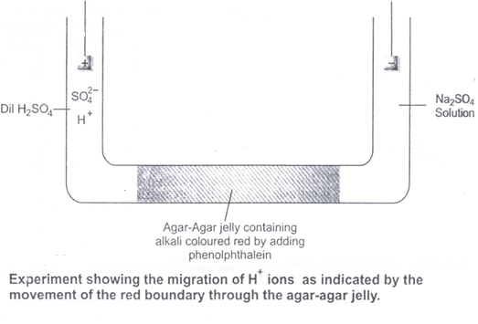
The apparatus used consists of a U-tube which has a long horizontal portion. It is fitted with electrodes in the side limbs. The horizontal portion is filled with a jelly of agar-agar treated with a trace of alkali. This is then made red by addition of a few drops of phenolphthalein. When the jelly is set, dilute sulphuric acid andsodium sulphate solution are added in the two different limbs of the tube. On passing the current, gradual discharge of the red colouris observed.

Q.1 In which limbs sulphuric acid and sodium sulphate solution are added?
______________________________________________________________________________________________________________________________________
Q.2 Identify the migrating ion responsible for discharge of red colour and state its type.
_______________________________________________________________
Q.3 State the role of phenolphthalein in above experiment.
__________________________________________________________________________________________________________________________________
Q.4State the reason for the discharge of red colour.
_____________________________________________________________________________________________________________________________________________________________________________________________________
Q.5 Draw arrows in above diagram to indicate the direction of migration of ion.
(USE GREEN COLOUR PEN)

Q.4Identify the limb to which the ion migrates.
______________________________________________________________________________________________________________________________________
Q.6 Demonstrate migration of an oppositely charged ion than one demonstrated in the above diagram with a neat labeled diagram.

- Movement of coloured ions
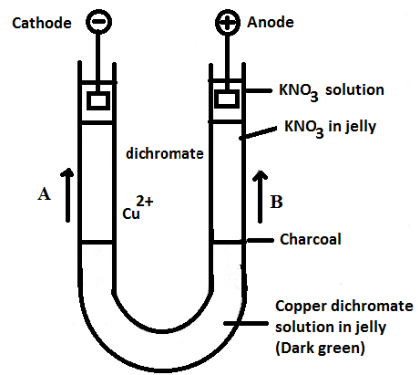

The lower part of a U-tube is filled with a 5 percent water-solution of agar-agar with a small amount of copper dichromate (CuSO₄+ K₂Cr₂0₇).The dark green colour sets to a jelly. The surface of the green solution in the two limbs of the U-tube is marked by a small amount of charcoal. In both the limbs is then placed a layer of solution of potassium nitrate and agar-agar. This is also allowed to set. Over this second layer is placed some solution of potassium nitrate in pure water and the two electrodes are inserted in it. As the current is turned on, rise of blue colour and reddish yellowcolour is seen in the two different limbs.

Q.1 State the reason for the rise of blue and reddish yellow colour.
_____________________________________________________________________________________________________________________________________________________________________________________________________
Q. 2 Match arrows A and B in the figure with blue and reddish yellow colour.
__________________________________________________________________________________________________________________________________
Q. 3 In which limb will blue colour rise?
________________________________________________________________
Q. 4 In which limb will reddish yellow colour rise?
_______________________________________________________________
Q. 5 Indicate arrows in the above figure to designate Cu²⁺ and dichromate presence in the limbs.
(USE GREEN COLOUR PEN)

Q. 6 What is the role of jelly in the above experiment?
_____________________________________________________________________________________________________________________________________________________________________________________________________

